## Readme document for example DDI instances B1, B9 and D39 of 2015-01-05

**1.**

**DASISH3.2 example DDI instance B1_2015-01-05.xml**

This example DDI instance is a fragment instance of a QuestionItem for the ESS Round 6 question B1.

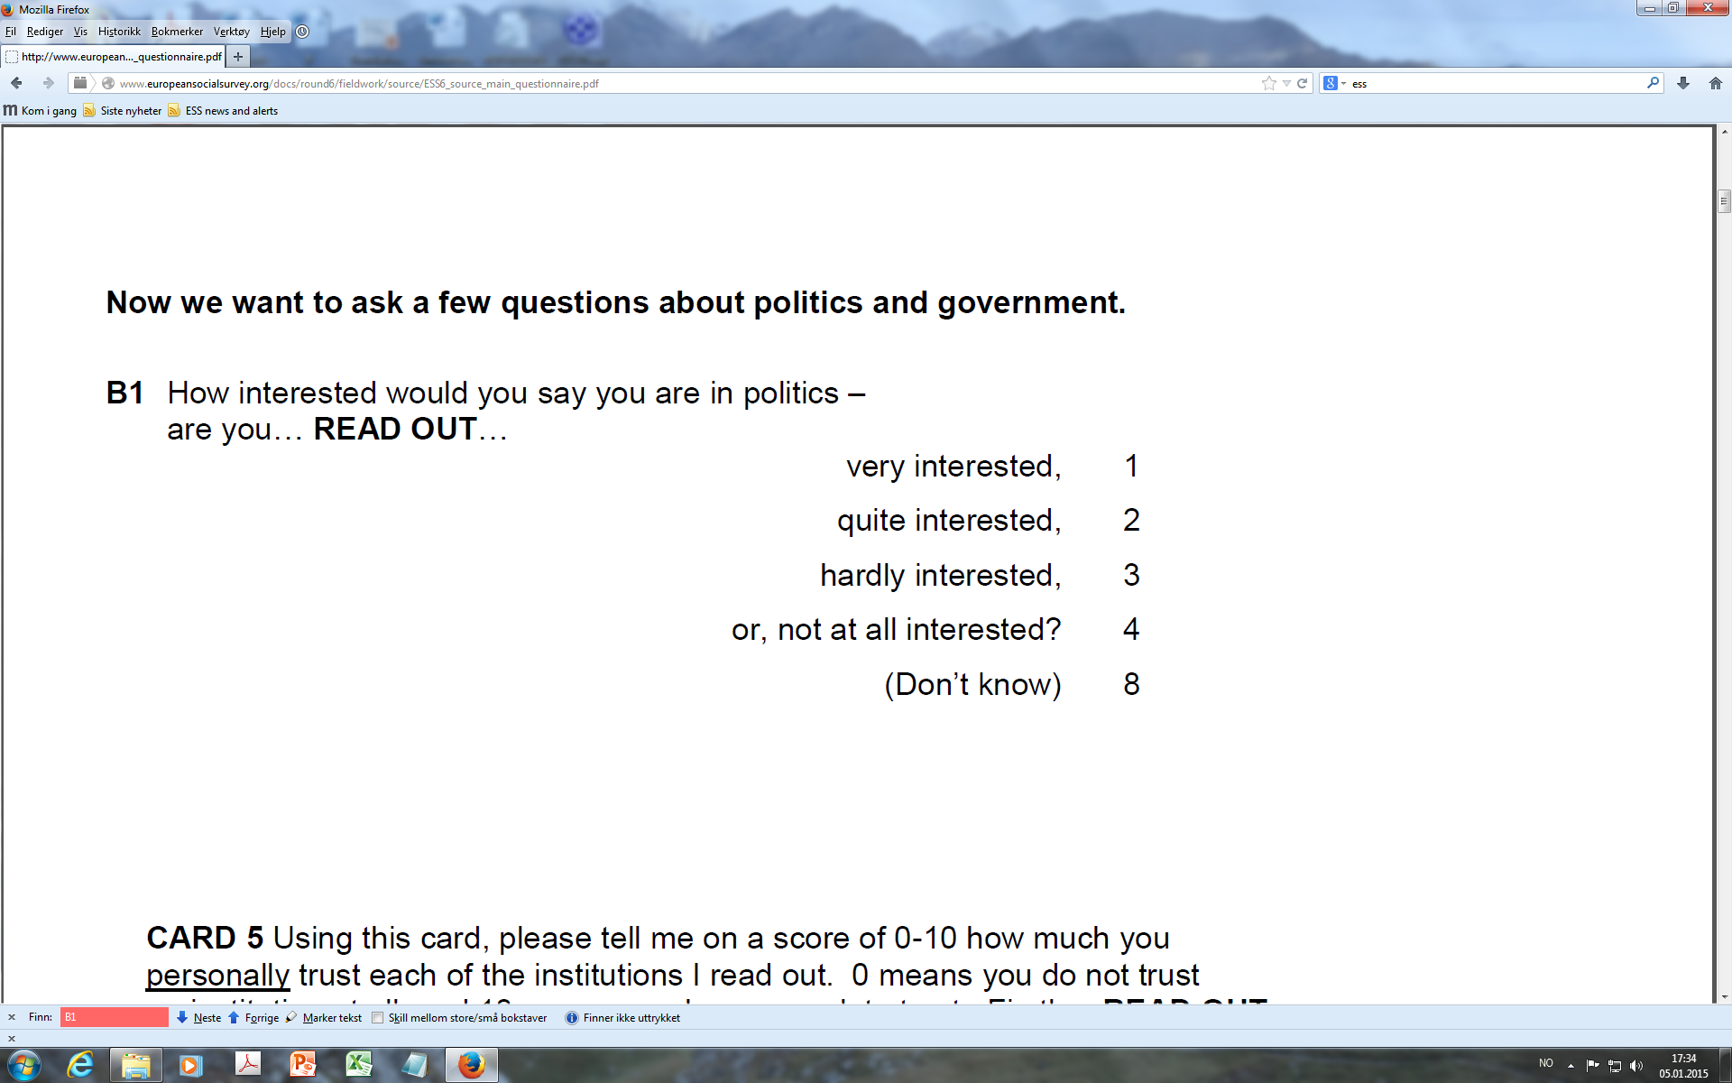

In this instance QuestionItemName has been used for the question number, and the interviewer instruction is referenced by the question scheme.

The agreed policy within the DASISH 3.2 project group is however to let only the more reusable parts of a question, like question text and response domain, make up the QuestionItem.

**2.**

**DASISH3.2 example DDI instance B9_2015-01-05.xml**

This example DDI instance is a fragment instance of a QuestionItem for the ESS Round 6 question B9.

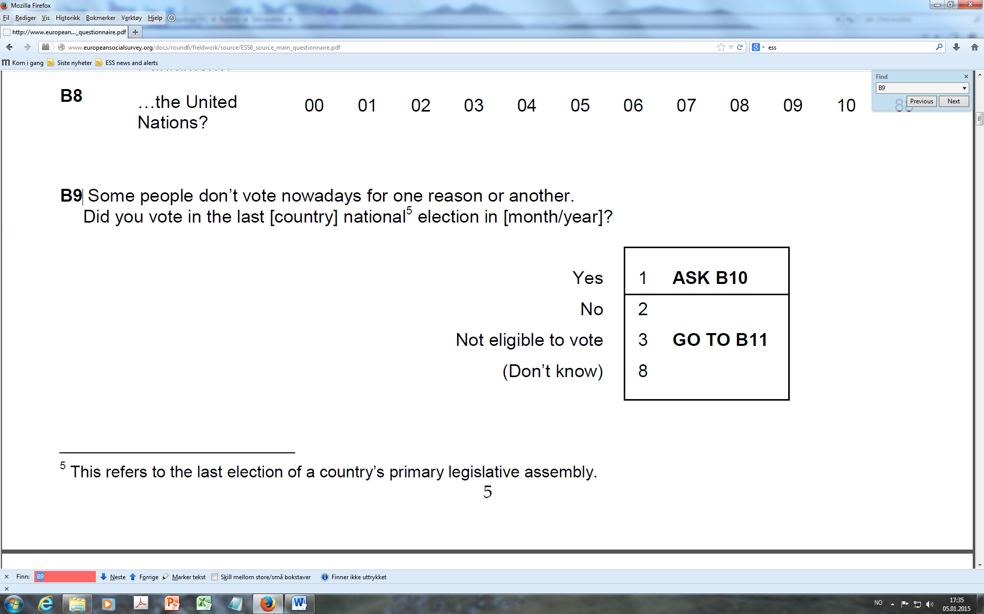

This instance shows missing values included as separate CodeLists that are referenced by the CodeDomain for the QuestionItem.

Sometimes a statement can be embedded in a question text. As SQP require the distinction between an introduction text and a request for an answer text, it has been agreed to allow this distinction in the tools. A workaround using div.class within question text is used for this. See lines 59 and 60 (distinction is made between ‘IntroductionToQuestion’ and ‘Question’).

**3.**

**DASISH3.2 example DDI instance D39_2015-01-05.xml**

This example DDI instance is a fragment instance of a QuestionConstruct (question as the applied use of a question as in the questionnaire) for the ESS Round 6 question D39.

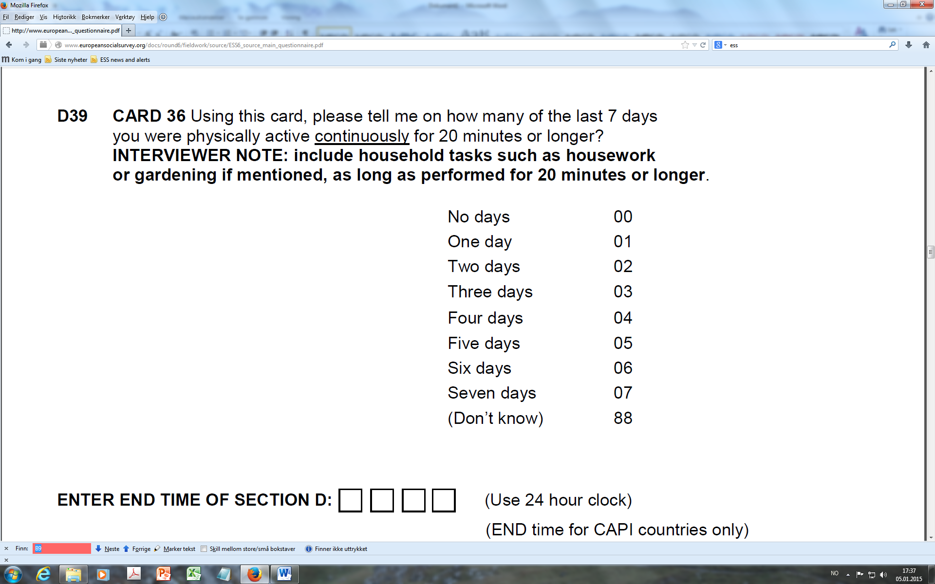

In this example ConstructName is used for the question number. Interviewer instructions are referenced by the QuestionConstruct.

A concept is included by reference in the QuestionItem referenced by the ControlConstruct.